**LAB 2**

**Roll No.: 200010003**

**Aim:** Designing logic gates using CMOS (Complementary Metal Oxide Semiconductor) logic.

**Summary of the experiment:** Study of logic gates using CMOS logic (Digital ICs), verifying their functionality and rigging up of circuits.

**Components used:** HCC4007UB IC, 1kOhm resistor array, DIP switches, LED displays, breadboard, power supply.

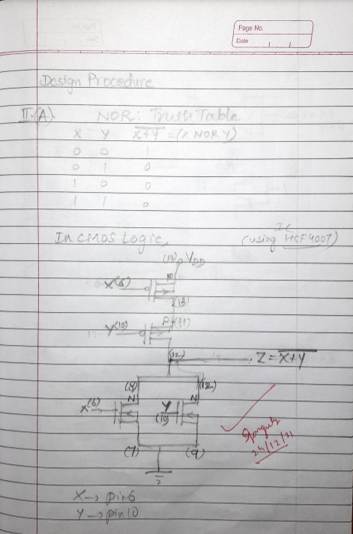**Design Procedure and Circuit Diagram:**

**Circuit Snapshots: *(attached below)***

**Results and Discussions:**

1. We have constructed the required logic gate NOR using CMOS logic, with the help of the HCC4007UB IC. We verified the functionality of the constructed circuit using truth tables of the logic gates
2. With the use of the CMOS logic family, we have greatly reduced the circuit complexity, and the density of logic functions per chip.

**Conclusion:**

We identified that the required logic gate was NOR, and then constructed logic circuits using the CMOS logic family, while verifying their functionality.